AIML:

1.Hypothesis Space:

In machine learning, the hypothesis space refers to the set of all possible functions (or models) that a learning algorithm can choose from when trying to learn from data. It defines the range of solutions that a machine learning model can explore to make predictions.

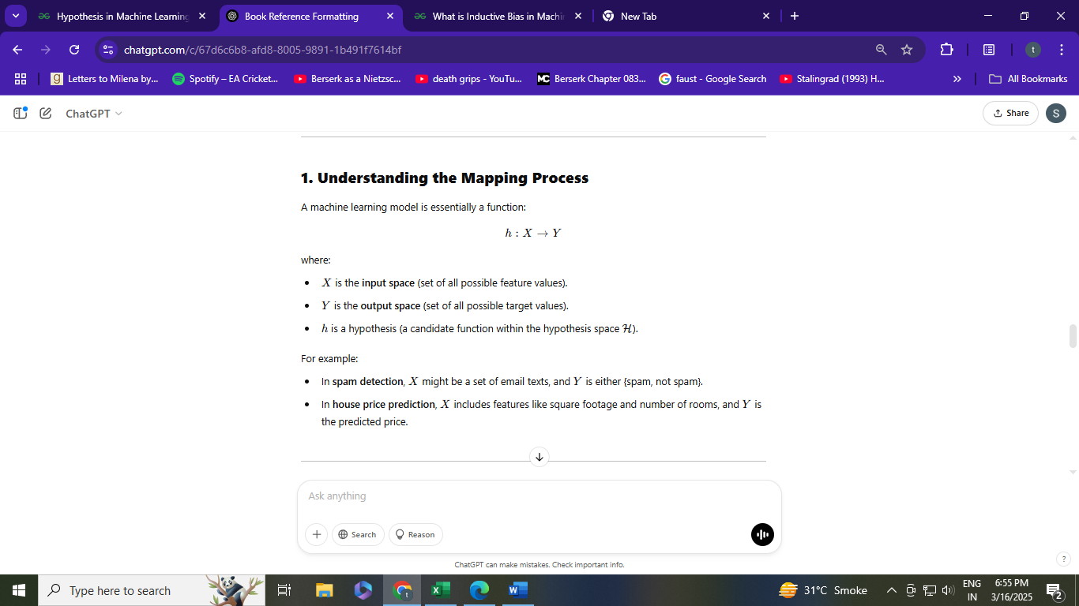

A hypothesis in [machine learning](https://www.geeksforgeeks.org/machine-learning/) is the model’s presumption regarding the connection between the input features and the result. It is an illustration of the mapping function that the algorithm is attempting to discover using the training set.

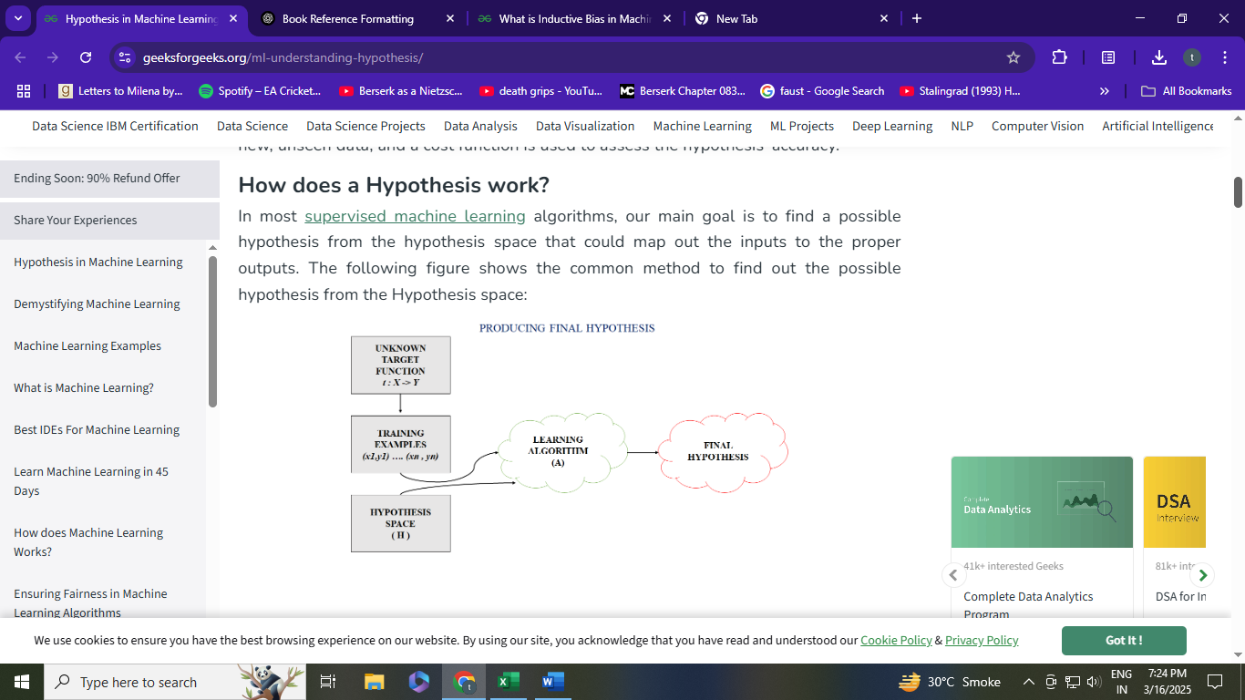

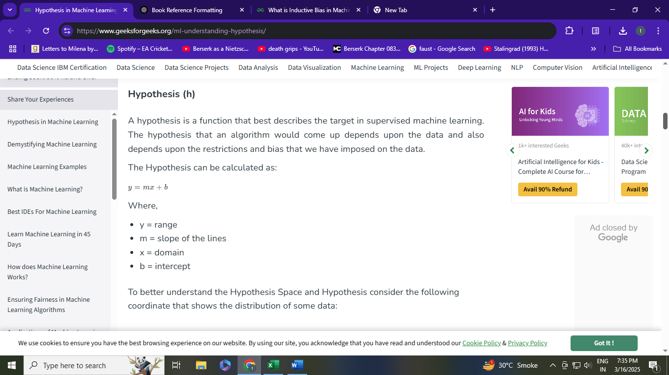

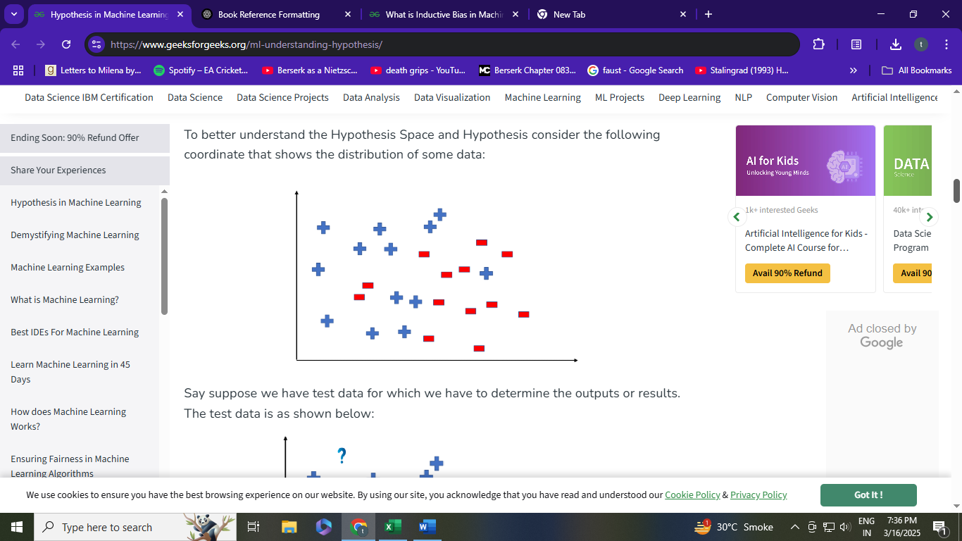

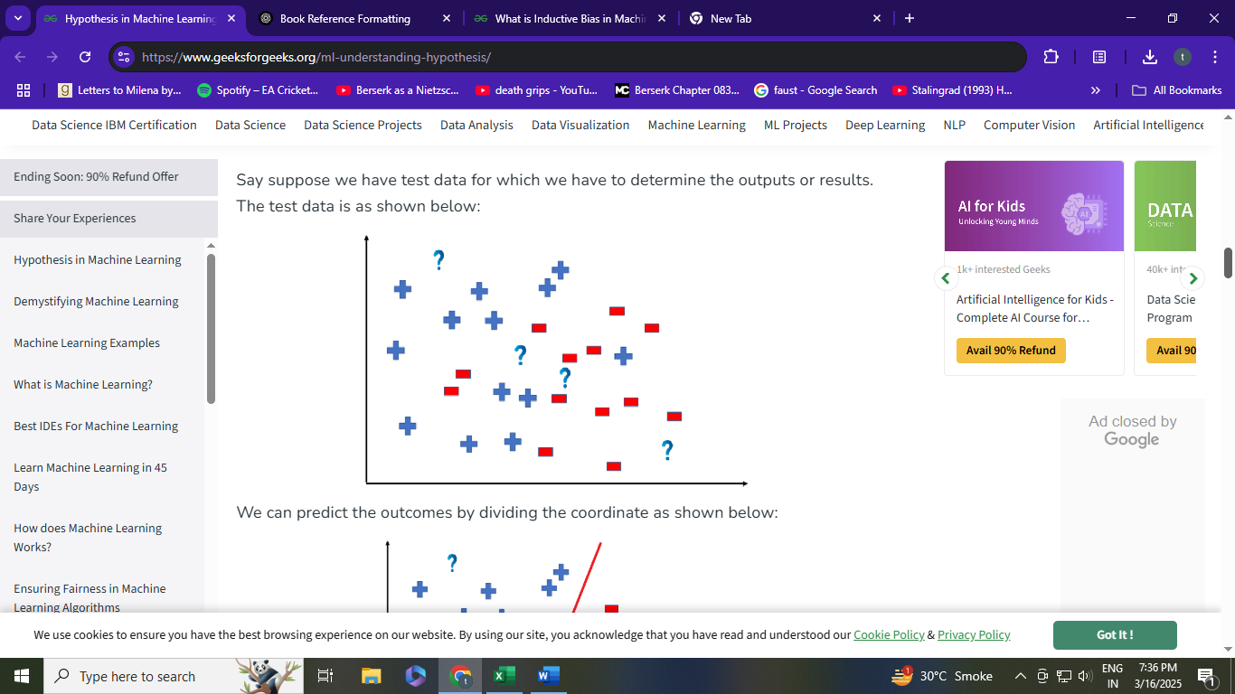

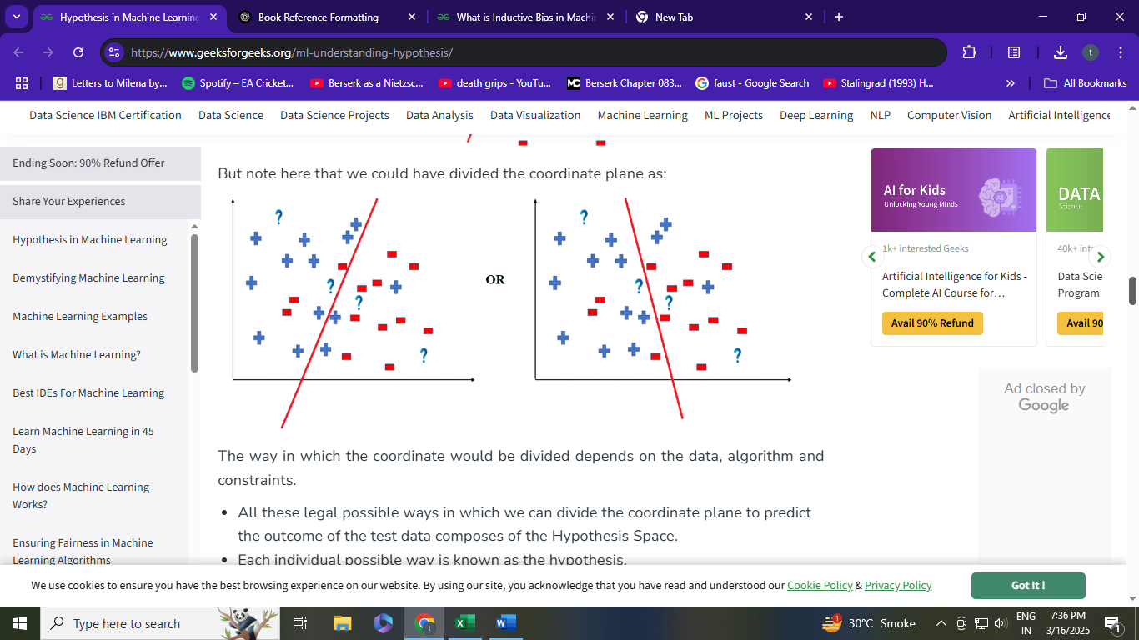

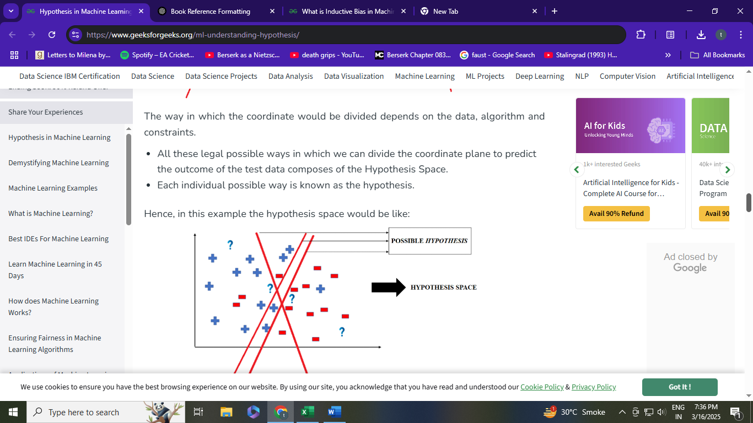

Inductive Bias

1. What is Inductive Bias?

Inductive bias refers to the set of assumptions that a machine learning algorithm uses to make predictions on unseen data. Since learning algorithms generalize from a limited set of training examples, they must rely on certain biases to make reasonable predictions for new inputs.

These biases help models learn efficiently but can also limit their ability to find the best hypothesis. A strong inductive bias can lead to good generalization but may also result in underfitting, while a weak or overly flexible bias can lead to overfitting.

2. Why is Inductive Bias Necessary?

In machine learning, we aim to learn a hypothesis hhh from a given hypothesis space H\mathcal{H}H that can generalize well to unseen data. However, because the hypothesis space is often infinite, an algorithm needs a way to prefer some hypotheses over others.

Inductive bias provides these preferences by guiding the learning algorithm toward hypotheses that are likely to perform well.

Example of Inductive Bias

Consider learning a function that maps input XXX to output YYY from the following dataset:

| XXX | YYY |
| --- | --- |
| 1 | 2 |
| 2 | 4 |
| 3 | 6 |

Given this data, different hypotheses could explain the relationship between XXX and YYY, such as:

* Hypothesis 1: Y=2XY = 2XY=2X (Linear relationship)
* Hypothesis 2: Y=X2+1Y = X^2 + 1Y=X2+1 (Nonlinear relationship)
* Hypothesis 3: Y=100Y = 100Y=100 for all XXX (Constant function)

A linear regression model has an inductive bias toward linear relationships, so it is more likely to choose Y=2XY = 2XY=2X, assuming a linear pattern.

7. How to Choose the Right Inductive Bias?

The choice of inductive bias depends on:  
✅ The nature of the data (e.g., images vs. text vs. structured data).  
✅ The complexity of the problem (simple vs. complex patterns).  
✅ Computational constraints (simpler models are often faster).  
✅ Generalization needs (avoiding overfitting vs. underfitting).

For example:

* If the relationship between XXX and YYY is known to be linear → Use a linear model.
* If data contains complex patterns and enough training examples → Use deep learning.
* If relationships between features are hierarchical → Use decision trees.

3. Types of Inductive Bias in Machine Learning

A) Language Bias

This bias restricts the hypothesis space by limiting the types of functions the model can consider.

Example:

* A linear regression model assumes that the relationship between input and output is linear.
* A decision tree assumes that the data can be split into hierarchical rules.

If the true relationship is nonlinear, a model with a linear bias will fail to capture it.

B) Preference Bias

Rather than restricting the hypothesis space, preference bias prioritizes certain hypotheses over others.

Example:

* Occam’s Razor Principle: Prefer simpler hypotheses over complex ones.
* Regularization in Neural Networks: Adds a penalty for large weights, encouraging simpler models.

For instance, in polynomial regression, a model with preference bias might prefer a quadratic function over a highly complex polynomial to avoid overfitting.

C) Algorithm-Specific Bias

Different machine learning algorithms have built-in biases that affect their learning behavior.

| Algorithm | Inductive Bias |
| --- | --- |
| Linear Regression | Prefers linear relationships |
| k-Nearest Neighbors (k-NN) | Assumes similar points belong to the same class |
| Decision Trees | Prefers axis-aligned splits (rules based on single feature thresholds) |
| Neural Networks | Can learn complex patterns but require large amounts of data to generalize well |

For example, k-NN assumes that nearby points belong to the same class, which works well when data has clear clusters but fails when the data is highly varied.

4. Inductive Bias and the Bias-Variance Tradeoff

Inductive bias directly affects the bias-variance tradeoff:

* Strong bias (simpler models) → Higher bias, lower variance → Risk of underfitting.
* Weak bias (more flexible models) → Lower bias, higher variance → Risk of overfitting.

For instance:

* A linear regression model has a strong bias for linearity and may not fit complex data well (underfitting).
* A deep neural network has a weak bias and can fit very complex patterns but may memorize training data (overfitting).

A good inductive bias balances generalization and expressiveness.

Training and Testing Data:

| Features | Training Data | Testing Data |
| --- | --- | --- |
| Purpose | The machine-learning model is trained using training data. The more training data a model has, the more accurate predictions it can make. | Testing data is used to evaluate the model's performance. |
| Exposure | By using the training data, the model can gain knowledge and become more accurate in its predictions. | Until evaluation, the testing data is not exposed to the model. This guarantees that the model cannot learn the testing data by heart and produce flawless forecasts. |
| Distribution | This training data distribution should be similar to the distribution of actual data that the model will use. | The distribution of the testing data and the data from the real world differs greatly. |
| Use | To stop overfitting, training data is utilized. | By making predictions on the testing data and comparing them to the actual labels, the performance of the model is assessed. |
| Size | Typically larger | Typically smaller |

1. Introduction to Training and Testing Sets

In machine learning, data is typically divided into three main subsets:

1. Training Set – The model learns patterns from this data.
2. Testing Set – Used to evaluate the model’s generalization on unseen data.
3. (Optional) Validation Set – Helps fine-tune the model's hyperparameters.

A good division ensures that the model generalizes well to new data rather than memorizing training examples.

2. Why Split Data?

Machine learning models aim to learn patterns from data, but they should also perform well on new, unseen examples. If a model is trained on all available data, there is no way to evaluate its true performance on unknown data.

Dividing data into training and testing sets allows us to:  
✅ Train the model on one portion of data (learning phase).  
✅ Evaluate the model on unseen data (generalization check).  
✅ Detect overfitting (when a model memorizes instead of generalizing).

3. Training Set vs. Testing Set

| Aspect | Training Set | Testing Set |
| --- | --- | --- |
| Purpose | Used to train the model | Used to evaluate performance |
| Data Used | Includes labeled data (input + correct output) | Includes unseen data (held out from training) |
| Size | 60%-80% of the dataset | 20%-40% of the dataset |
| Outcome | The model learns patterns from this data | Measures accuracy, precision, recall, etc. |

Example:

* Suppose we have 10,000 customer records for fraud detection.
  + Training Set: 8,000 records → Used to train the fraud detection model.
  + Testing Set: 2,000 records → Used to check how well the model predicts fraud on unseen data.

4. How to Split Data? (Common Approaches)

A) Random Split (Basic Approach)

* Data is randomly shuffled and split into training (e.g., 80%) and testing (e.g., 20%).
* Works well for large datasets.

B) Stratified Split (For Imbalanced Data)

* Ensures that the class distribution remains the same in both training and testing sets.
* Useful for classification problems where some classes are rare.

🔹 Example: In fraud detection, if only 2% of transactions are fraudulent, a simple random split may result in no fraud cases in the test set.

* Stratified sampling ensures both training and testing sets have the same proportion of fraud cases.
* C) k-Fold Cross-Validation (For Small Datasets)
* Splits data into k subsets (folds), trains on k-1 folds, and tests on the remaining fold.
* Repeats the process k times, each time using a different fold as the test set.
* Used when data is limited.
* 🔹 Example: k=5 (5-fold cross-validation)
* Split data into 5 equal parts.
* Train on 4 parts, test on 1 part.
* Repeat 5 times, using a different part as the test set each time.
* Average the performance over all 5 runs

Cross-Validation in Machine Learning:

Cross-validation is a technique used to assess the generalization ability of a machine learning model. Instead of using a single train-test split, cross-validation repeatedly splits the dataset into training and testing subsets to improve the reliability of model evaluation.

It helps in:  
✅ Avoiding overfitting.  
✅ Getting a more stable and robust estimate of model performance.  
✅ Making better use of limited data.

2. Why Use Cross-Validation?

In a standard train-test split, performance evaluation depends heavily on how the data was divided. A lucky split may lead to a better-than-expected result, while an unlucky split may show worse performance.

Cross-validation solves this by averaging results over multiple train-test splits, ensuring a more reliable measure of accuracy.

Example Scenario

Imagine you are building a spam email classifier.

* If you train on 80% of emails and test on 20%, the accuracy may vary depending on which emails end up in the test set.
* Cross-validation ensures that every email gets tested once, providing a more stable estimate of model accuracy.

3. Types of Cross-Validation

A) k-Fold Cross-Validation (Most Common)

* Splits the dataset into k equal-sized subsets (folds).
* Trains on k-1 folds and tests on the remaining 1 fold.
* Repeats this process k times, each time using a different fold as the test set.
* Final accuracy is the average of k iterations.

🔹 Example: 5-Fold Cross-Validation

1. Split data into 5 parts (folds).
2. Train on Folds 1-4, test on Fold 5.
3. Train on Folds 1,2,3,5, test on Fold 4.
4. Repeat until every fold has been used as a test set once.
5. Take the average accuracy over all 5 runs.

B) Stratified k-Fold Cross-Validation (For Imbalanced Data)

* Ensures that each fold has the same class distribution as the original dataset.
* Useful when dealing with imbalanced classification problems (e.g., fraud detection, rare disease prediction).

🔹 Example: Fraud Detection (Class Imbalance)

* If only 2% of transactions are fraudulent, random k-fold may place only non-fraud cases in a test fold.
* Stratified k-Fold ensures that each fold contains 2% fraud cases.
* 4. Choosing the Right Cross-Validation Strategy

| Cross-Validation Type | Best For | When to Avoid |
| --- | --- | --- |
| k-Fold (k=5 or 10) | General datasets | Very small datasets |
| Stratified k-Fold | Imbalanced classification problems | Balanced datasets |
| Leave-One-Out (LOO-CV) | Small datasets | Large datasets (too slow) |
| Leave-P-Out (LPO-CV) | Small datasets | Large datasets |
| Time-Series CV | Time-dependent data (e.g., forecasting) | Non-sequential data |

Evaluation using Confusion Matrix :

Cross-Validation in Machine Learning (Based on Given References)

1. What is Cross-Validation?

Cross-validation is a technique used to assess the generalization ability of a machine learning model. Instead of using a single train-test split, cross-validation repeatedly splits the dataset into training and testing subsets to improve the reliability of model evaluation.

It helps in:  
✅ Avoiding overfitting.  
✅ Getting a more stable and robust estimate of model performance.  
✅ Making better use of limited data.

2. Why Use Cross-Validation?

In a standard train-test split, performance evaluation depends heavily on how the data was divided. A lucky split may lead to a better-than-expected result, while an unlucky split may show worse performance.

Cross-validation solves this by averaging results over multiple train-test splits, ensuring a more reliable measure of accuracy.

Example Scenario

Imagine you are building a spam email classifier.

* If you train on 80% of emails and test on 20%, the accuracy may vary depending on which emails end up in the test set.
* Cross-validation ensures that every email gets tested once, providing a more stable estimate of model accuracy.

3. Types of Cross-Validation

A) k-Fold Cross-Validation (Most Common)

* Splits the dataset into k equal-sized subsets (folds).
* Trains on k-1 folds and tests on the remaining 1 fold.
* Repeats this process k times, each time using a different fold as the test set.
* Final accuracy is the average of k iterations.

🔹 Example: 5-Fold Cross-Validation

1. Split data into 5 parts (folds).
2. Train on Folds 1-4, test on Fold 5.
3. Train on Folds 1,2,3,5, test on Fold 4.
4. Repeat until every fold has been used as a test set once.
5. Take the average accuracy over all 5 runs.

B) Stratified k-Fold Cross-Validation (For Imbalanced Data)

* Ensures that each fold has the same class distribution as the original dataset.
* Useful when dealing with imbalanced classification problems (e.g., fraud detection, rare disease prediction).

🔹 Example: Fraud Detection (Class Imbalance)

* If only 2% of transactions are fraudulent, random k-fold may place only non-fraud cases in a test fold.
* Stratified k-Fold ensures that each fold contains 2% fraud cases.

Evaluation Using Confusion Matrix (Based on Given References)

1. What is a Confusion Matrix?

A confusion matrix is a performance evaluation metric for classification problems. It helps understand how well a model distinguishes between different classes by showing the counts of actual vs. predicted classifications.

It is structured as a matrix with four key values:

|  | Predicted Positive | Predicted Negative |
| --- | --- | --- |
| Actual Positive | True Positive (TP) | False Negative (FN) |
| Actual Negative | False Positive (FP) | True Negative (TN) |

📌 Terminology:  
✅ True Positive (TP) → Model correctly predicted positive cases.  
✅ True Negative (TN) → Model correctly predicted negative cases.  
🚫 False Positive (FP) → Model incorrectly predicted positive when it was actually negative (Type I Error).  
🚫 False Negative (FN) → Model incorrectly predicted negative when it was actually positive (Type II Error).

Example: Spam Email Classification

* TP: Spam email correctly identified as spam.
* TN: Normal email correctly identified as normal.
* FP: Normal email wrongly classified as spam.
* FN: Spam email wrongly classified as normal.

2. Why Use a Confusion Matrix?

✅ Provides detailed insights into classification errors.  
✅ Helps calculate various evaluation metrics.  
✅ Useful when dealing with imbalanced datasets.

⚠️ Limitation:  
🚫 Does not provide a single performance metric (like accuracy).

4. Metrics Derived from the Confusion Matrix

A) Accuracy

📌 Measures overall correctness:

Accuracy=TP+TNTP+TN+FP+FN\text{Accuracy} = \frac{TP + TN}{TP + TN + FP + FN}Accuracy=TP+TN+FP+FNTP+TN​

python

CopyEdit

from sklearn.metrics import accuracy_score

accuracy = accuracy_score(y_true, y_pred)

print("Accuracy:", accuracy)

🔹 Limitations  
🚫 Not reliable for imbalanced datasets (e.g., if 95% are "No Disease," the model could predict all as "No Disease" and still get 95% accuracy).

B) Precision (Positive Predictive Value)

📌 Out of all predicted positive cases, how many are actually positive?

Precision=TPTP+FP\text{Precision} = \frac{TP}{TP + FP}Precision=TP+FPTP​

python

CopyEdit

from sklearn.metrics import precision_score

precision = precision_score(y_true, y_pred)

print("Precision:", precision)

✅ High Precision → Few false positives (good when false positives are costly, e.g., spam filtering).

🚫 Low Precision → Many false positives (misclassifies negatives as positives).

C) Recall (Sensitivity / True Positive Rate)

📌 Out of all actual positive cases, how many were predicted correctly?

Recall=TPTP+FN\text{Recall} = \frac{TP}{TP + FN}Recall=TP+FNTP​

python

CopyEdit

from sklearn.metrics import recall_score

recall = recall_score(y_true, y_pred)

print("Recall:", recall)

✅ High Recall → Few false negatives (good when false negatives are costly, e.g., disease detection).

🚫 Low Recall → Many false negatives (misses too many actual positives).

D) F1 Score (Harmonic Mean of Precision & Recall)

📌 Balances precision and recall:

F1 Score=2×Precision×RecallPrecision+Recall\text{F1 Score} = 2 \times \frac{\text{Precision} \times \text{Recall}}{\text{Precision} + \text{Recall}}F1 Score=2×Precision+RecallPrecision×Recall​

python

CopyEdit

from sklearn.metrics import f1_score

f1 = f1_score(y_true, y_pred)

print("F1 Score:", f1)

✅ Useful when dealing with imbalanced datasets.

**Precision in Machine Learning (Based on Given References)**

**1. What is Precision?**

Precision is a key evaluation metric used in classification problems. It measures **how many of the predicted positive cases are actually positive**.

Precision=TPTP+FP\text{Precision} = \frac{TP}{TP + FP}Precision=TP+FPTP​

Where:

* **TP (True Positives)** = Correctly predicted positive cases.
* **FP (False Positives)** = Incorrectly predicted positive cases (actual negative but predicted as positive).

**2. Why is Precision Important?**

**A) High Precision is Useful When False Positives are Costly**

* **Example 1: Spam Detection**
  + If an email is mistakenly classified as spam (FP), the user **misses an important email**.
  + We want **high precision** to reduce the number of **legitimate emails marked as spam**.
* **Example 2: Medical Diagnosis**
  + Suppose a test predicts if a person has cancer.
  + A **false positive (FP)** means a healthy person is incorrectly diagnosed as having cancer, leading to **unnecessary anxiety and tests**.
  + We need **high precision** to ensure that most positive diagnoses are correct.

📌 **High precision means fewer false positives.**

**B) Low Precision Means Many False Positives (FPs are costly)**

* **Example 1: Fraud Detection**
  + If a bank incorrectly flags legitimate transactions as fraudulent, customers will be **inconvenienced**.
  + We need **high precision** to ensure only true fraudulent transactions are detected.
* **Example 2: Search Engine Results**
  + A search engine should **only return relevant results** for a query.
  + A low-precision model might return **irrelevant** pages, leading to poor user experience.

📌 **Low precision means many false positives (irrelevant results, incorrect fraud alerts, unnecessary medical tests).**

If we have the following confusion matrix:

|  | **Predicted Positive** | **Predicted Negative** |
| --- | --- | --- |
| **Actual Positive** | **5 (TP)** | **2 (FN)** |
| **Actual Negative** | **1 (FP)** | **7 (TN)** |

Using the formula:

Precision=TPTP+FP=55+1=0.83\text{Precision} = \frac{TP}{TP + FP} = \frac{5}{5 + 1} = 0.83Precision=TP+FPTP​=5+15​=0.83

| **Metric** | **Formula** | **Best for...** |
| --- | --- | --- |
| **Accuracy** | TP+TNTP+TN+FP+FN\frac{TP + TN}{TP + TN + FP + FN}TP+TN+FP+FNTP+TN​ | Balanced datasets |
| **Precision** | TPTP+FP\frac{TP}{TP + FP}TP+FPTP​ | When FP is costly (e.g., fraud detection, medical diagnosis) |
| **Recall (Sensitivity)** | TPTP+FN\frac{TP}{TP + FN}TP+FNTP​ | When FN is costly (e.g., disease detection) |
| **F1 Score** | 2×Precision×RecallPrecision+Recall2 \times \frac{\text{Precision} \times \text{Recall}}{\text{Precision} + \text{Recall}}2×Precision+RecallPrecision×Recall​ | Balanced trade-off between precision and recall |

📌 **High Precision** reduces false positives.  
📌 **High Recall** reduces false negatives.  
📌 **F1-Score** balances Precision and Recall.

**5. When to Prioritize Precision Over Recall?**

| **Scenario** | **Should Precision Be High?** | **Should Recall Be High?** |
| --- | --- | --- |
| **Spam Filtering** | ✅ Yes (avoid marking useful emails as spam) | 🚫 No (missing a spam email isn’t critical) |
| **Medical Tests (e.g., Cancer Diagnosis)** | 🚫 No | ✅ Yes (avoid missing a cancer case) |
| **Fraud Detection** | ✅ Yes (avoid blocking legitimate transactions) | ✅ Yes (avoid missing fraud cases) |
| **Search Engines** | ✅ Yes (only show relevant results) | 🚫 No |

**7. Conclusion**

📌 **Precision is crucial when false positives are costly** (spam detection, fraud detection, search engines).  
📌 **It should be balanced with recall using the F1-score**.  
📌 **Precision vs. Recall tradeoff** depends on the use case (e.g., spam filters need high precision, medical tests need high recall).  
📌 **Threshold tuning affects precision and recall, requiring a precision-recall tradeoff curve**.

Would you like a **real dataset example** with detailed precision-recall analysis? 🚀

**Recall, Bias, and Variance in Machine Learning (Based on Given References)**

**1. Recall (Sensitivity / True Positive Rate)**

**Definition**

Recall measures how well a model correctly identifies positive instances. It is also called **sensitivity** or **true positive rate (TPR)**.

Recall=TPTP+FN\text{Recall} = \frac{TP}{TP + FN}Recall=TP+FNTP​

Where:

* **TP (True Positives)** → Correctly predicted positive cases.
* **FN (False Negatives)** → Actual positive cases wrongly classified as negative.

**Why is Recall Important?**

Recall is **critical when false negatives (FN) are costly**.

✅ **High Recall** → The model captures most positive cases.  
🚫 **Low Recall** → The model **misses many actual positive cases**.

**Example: When is High Recall Important?**

| **Application** | **Impact of False Negatives (FN)** | **Need High Recall?** |
| --- | --- | --- |
| **Medical Diagnosis (Cancer, COVID-19)** | Missing a real case could be life-threatening. | ✅ Yes |
| **Fraud Detection** | Missing fraud cases leads to financial loss. | ✅ Yes |
| **Spam Filtering** | Missing spam is not critical. | 🚫 No |
| **Search Engines** | Not showing a relevant page reduces user satisfaction. | ✅ Yes |

**Tradeoff Between Recall and Precision**

* **High Recall → Low Precision** (Model captures all positives but may misclassify some negatives as positives).
* **High Precision → Low Recall** (Model is very strict, reducing false positives but missing some real positives).
* **Balance is achieved with the F1-score**:

F1=2×Precision×RecallPrecision+RecallF1 = 2 \times \frac{\text{Precision} \times \text{Recall}}{\text{Precision} + \text{Recall}}F1=2×Precision+RecallPrecision×Recall​

**2. Bias and Variance Tradeoff**

**Definition**

Bias and variance are two key sources of error in machine learning models. Understanding their tradeoff helps in building well-generalized models.

| **Error Type** | **Description** | **Effect** |
| --- | --- | --- |
| **Bias** | Error due to **wrong assumptions** in the learning algorithm. | High bias leads to **underfitting** (too simple model). |
| **Variance** | Error due to **model sensitivity to training data**. | High variance leads to **overfitting** (model captures noise). |

Total Error=Bias2+Variance+Irreducible Noise\text{Total Error} = \text{Bias}^2 + \text{Variance} + \text{Irreducible Noise}Total Error=Bias2+Variance+Irreducible Noise

**Impact of Bias and Variance on Model Performance**

| **Model Type** | **Bias** | **Variance** | **Generalization Ability** |
| --- | --- | --- | --- |
| **Underfitting (High Bias, Low Variance)** | High | Low | Poor |
| **Overfitting (Low Bias, High Variance)** | Low | High | Poor |
| **Balanced Model** | Medium | Medium | Good |

**A) High Bias (Underfitting)**

🔹 **Definition**: The model is too simple and **fails to capture patterns** in the data.  
🔹 **Causes**:

* Using a **linear model** on non-linear data.
* Too **few features**.
* Too much **regularization** (L1, L2).  
  🔹 **Effects**:
* **High training error**.
* **High test error** (poor generalization).  
  🔹 **Fixes**:  
  ✅ Use **complex models** (deep learning, polynomial regression).  
  ✅ **Add more features**.  
  ✅ Reduce **regularization**.

📌 **Example:**  
A model predicting **house prices** using **only one feature (size)** will **underfit** because prices depend on many factors (location, amenities, etc.).

**B) High Variance (Overfitting)**

🔹 **Definition**: The model is too complex and **learns noise** from training data.  
🔹 **Causes**:

* **Too many features**.
* **Not enough training data**.
* **No regularization**.  
  🔹 **Effects**:
* **Low training error**.
* **High test error** (model doesn’t generalize well).  
  🔹 **Fixes**:  
  ✅ Use **simpler models** (regularization, pruning).  
  ✅ **Reduce features** (feature selection).  
  ✅ Increase **training data** (data augmentation).

📌 **Example:**  
A neural network with **100 hidden layers** trained on a **small dataset** will overfit and perform badly on new data.

**C) Bias-Variance Tradeoff**

| **Scenario** | **Solution** |
| --- | --- |
| High Bias (Underfitting) | Increase model complexity, add more features |
| High Variance (Overfitting) | Reduce model complexity, use regularization, increase training data |
| Balanced Model | Good training and test performance |

**3. Bias, Variance, and Recall**

**A) High Recall and Bias-Variance Tradeoff**

* **High recall models may have high variance** (they capture all positive cases, even if some are wrong).
* **Low recall models may have high bias** (they miss too many positives).
* The goal is to balance both.

**B) Bias and Variance in Different ML Models**

| **Model** | **Bias** | **Variance** | **Generalization Ability** |
| --- | --- | --- | --- |
| **Linear Regression** | High | Low | Poor for non-linear data |
| **Decision Trees** | Low | High | High risk of overfitting |
| **Random Forest** | Medium | Medium | Good |
| **Neural Networks** | Varies | Varies | Depends on architecture |